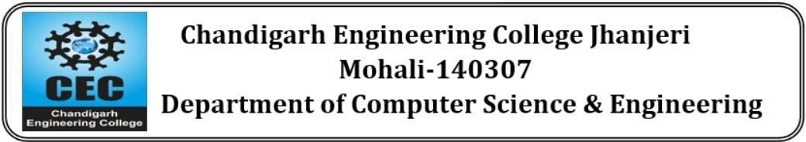

DietWell: AI-Powered Personalized Nutrition and Healthy Diet Planning System

Project- I

BACHELOR OF TECHNOLOGY
(Computer Science and Engineering.)



SUBMITTED BY:

Name :Abhishek Kumar
Roll No : 2230723

FEB 2026

Under the Guidance of
Dr Ashima shahi
Associate professor

Department of Computer Science & Engineering Chandigarh Engineering College Jhanjeri
Mohali - 140307

Table of Contents

SNo | Contents | Page No
1. | Introduction | 3
2. | Brief Literature Survey | 4
3. | Problem Formulation | 5
4. | Objectives | 6
5. | Methodology / Planning of Work | 7-8
6. | Facilities Required for Proposed Work | 9
7. | Ethical Considerations | 10
8. | Expected Outcomes | 11
9. | Future Scope | 12
10. | References | 13

Introduction
In today’s fast-paced world, maintaining a healthy lifestyle has become a major challenge for many people. Irregular eating habits, lack of nutritional awareness, busy schedules, and dependence on fast food have contributed to increasing health issues such as obesity, diabetes, malnutrition, and lifestyle-related diseases. Although a large amount of diet and fitness information is available online, most users struggle to find guidance that is personalized, practical, and easy to follow according to their individual needs.
DietWell is designed as an intelligent web-based platform that helps users achieve better health through personalized diet planning and nutrition management. Instead of providing one common diet chart for everyone, the system focuses on user-specific factors such as age, weight, height, lifestyle, fitness goals, food preferences, and daily calorie requirements. Based on these inputs, DietWell generates customized meal plans that are realistic, balanced, and goal-oriented.
The platform combines health awareness with modern technology to create a user-friendly digital wellness assistant. It allows users to explore healthy meal options, calculate calories, monitor daily progress, and receive recommendations that support weight loss, weight gain, fitness improvement, or healthy maintenance. By simplifying nutrition planning, the system helps users make smarter food choices in their daily lives.
Core Functional Modules
The platform centralizes healthy living into four major modules:
Personalized Diet Planning: Generates custom meal plans based on user profile and health goals.
Calorie & Nutrition Tracking: Monitors daily calorie intake and nutritional balance.
Progress Monitoring: Tracks user consistency, goals, and improvements over time.
Healthy Guidance & Recommendations: Suggests better food habits, meal alternatives, and wellness tips.
Smart and Adaptive Approach
The true strength of DietWell lies in its adaptive nature. Human health goals are dynamic and may change over time due to progress, lifestyle changes, or medical needs. A static diet chart may fail to remain effective in such situations

Brief Literature Survey

Current research and existing digital solutions in health and nutrition management can be broadly divided into three major categories: fitness tracking applications, expert-based diet consultation systems, and AI-driven personalized wellness platforms. While each category provides useful features, they also have limitations that prevent them from becoming a complete solution for long-term health management.
1. Fitness Tracking Applications
Applications such as calorie counters and activity trackers help users monitor steps, calories burned, water intake, and daily exercise routines. These platforms are effective for tracking progress and maintaining motivation. However, they mainly focus on recording data and often lack personalized meal planning based on the user’s body profile, goals, and dietary preferences.
2. Expert-Based Diet Consultation Systems
Traditional nutrition consultation systems allow users to receive diet plans from doctors or professional dietitians. These services provide reliable and medically guided recommendations. However, they may be expensive, time-consuming, and not always accessible to every user. Regular follow-up and continuous monitoring can also be difficult for many individuals.
3. AI-Based Personalized Wellness Platforms
Recent advancements in artificial intelligence have enabled smart systems that can generate customized diet plans and health recommendations. These platforms use user data such as age, weight, activity level, and fitness goals to create better suggestions. Despite this progress, many current systems are limited in adaptability, progress monitoring, and long-term user engagement.

Problem Formulation

The fundamental objective of DietWell is to design an intelligent system that generates and continuously improves personalized diet plans according to user needs. Given a user’s health goal G, personal profile P, and daily progress data D, the system must create and update an optimized nutrition plan N that maximizes health improvement and user consistency.
To achieve this objective, the platform addresses four major technical challenges:
1. Personalized Plan Generation
Every user has different health conditions, body types, and goals. A common diet plan cannot suit everyone. DietWell must analyze user inputs such as age, weight, height, BMI, activity level, and food preferences to generate customized meal recommendations.
2. Adaptive Feedback System
Health goals and body requirements change over time. A static plan may become ineffective after progress or lifestyle changes. The system introduces dynamic adjustment logic that monitors user performance and modifies calorie targets, meal portions, and nutrition balance whenever required.
3. Secure User Data Management
The platform stores personal and health-related information, so privacy and security are essential. DietWell uses secure authentication, encrypted passwords, and protected user profiles to ensure safe data handling.
4. Reliable Nutrition Guidance
Online health information is often confusing or misleading. The system must provide trusted recommendations by using verified nutrition sources and structured logic instead of random or unreliable content.
By solving these challenges, DietWell aims to deliver a smart, secure, and user-friendly solution for effective health and nutrition management.

Objectives

To construct a robust and well-validated bot detection system, our project is guided by three primary objectives. These goals provide a clear roadmap, breaking the project down into logical, sequential stages that encompass everything from foundational data work to the rigorous validation of our final model. Each objective is designed to build upon the last, ensuring a systematic and thorough approach.

Our first objective is to prepare a high-quality, model-ready dataset. Raw data is rarely suitable for direct use in machine learning, and this foundational stage is critical for the success of the entire project. This involves a meticulous process of data cleaning to handle any missing values or inconsistencies. We will then perform essential data transformations, such as converting categorical features like Verified into a numerical format (0 or 1) and ensuring all numerical data is scaled appropriately to prevent features with large ranges (like follower counts) from disproportionately influencing the model.

The second objective is to engineer a rich and predictive feature set. A machine learning model's performance is fundamentally limited by the quality of the data it is given. Therefore, a major part of our work will be to move beyond the raw variables in the dataset and create new, more informative features. This creative process will involve deriving metrics like the age of an account in days from its creation date, calculating ratios that capture behavioral patterns (e.g., tweet frequency per day), and extracting signals from text fields (e.g., the number of digits in a username). This will provide the model with a much richer "vocabulary" to describe and differentiate between user types.

Our final and most critical objective is to develop, train, and rigorously evaluate a classification model. This involves more than just fitting a single algorithm to the data. We will begin by establishing a baseline performance with a simple model like Logistic Regression. We will then build and tune more complex models, such as Random Forest or Gradient Boosting, to push for higher performance. The evaluation process will be comprehensive, using techniques like cross-validation for a robust assessment and analyzing a suite of metrics—including precision, recall, and the AUC-ROC curve—to understand the real-world trade-offs of our model's decisions, particularly the balance between catching bots and incorrectly flagging legitimate users.

Methodology

The development of PlacementPath AI follows a systematic, five-phase methodology, transitioning from core security infrastructure to complex, adaptive AI logic.
Phase 1: Robust Backend Architecture
The initial phase focused on establishing a secure, scalable foundation using Spring Boot 3.2 and PostgreSQL. A primary objective was the implementation of a stateless authentication system using JSON Web Tokens (JWT) and BCrypt password hashing. The database schema was designed to support multi-tenancy, with core entities including User profiles (storing skill levels and target roles) and Roadmap objects that store the AI-generated JSON structures.
Phase 2: AI Integration & Sanitization
The core intelligence was realized by integrating the Groq API (utilizing the LLaMA3 model) via Spring WebClient. To bridge the gap between "creative" AI and "structured" software, specific sanitization layers were built. This includes stripMarkdown() to clean AI-generated text and a custom ResourceBank.java utility. The latter serves as a "hallucination filter," replacing unreliable AI-suggested URLs with verified links from platforms like LeetCode and GeeksforGeeks.
Phase 3: Dynamic React Interface
The frontend was developed using React 18 and Vite 5 to ensure a high-performance User Experience (UX). A centralized AuthContext manages JWT states, while Axios interceptors handle the automatic injection of security tokens into API requests. The UI is component-based, featuring WeekCard and TopicItem modules that allow students to visualize their 6-week journey and track tasks through interactive progress bars.
Phase 4: Adaptive Intelligence (Current Focus)
Development is currently centered on the Feedback Loop. The ProgressAnalyzer.java component audits student activity to detect mastery gaps—specifically categories falling below the 50% completion threshold. When a weakness is flagged, AdjustmentService.java constructs a specialized prompt that instructs the LLM to recalibrate the remaining roadmap, shifting the academic weight toward the identified weak areas.
Phase 5: Scalability & Optimization Future milestones focus on deepening student engagement and ensuring professional-grade deployment:
- Knowledge Management: A per-topic CRUD module for personalized notes.
- Assessment Layer: A quiz system featuring AI-generated questions to validate learning.
- Data Visualization: An advanced analytics dashboard to plot category-wise trends.
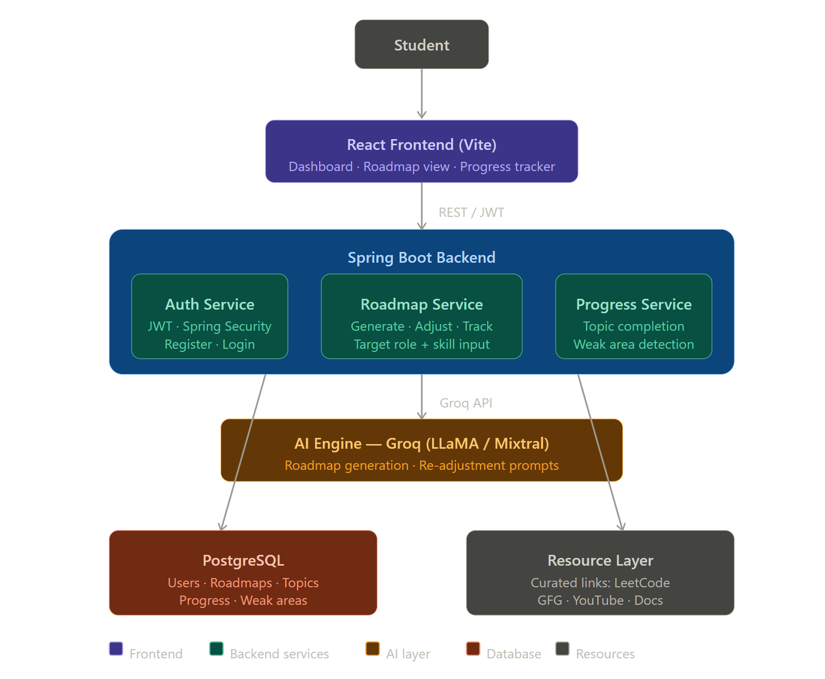

Facilities Required for Proposed Work

The development of Diet well AI utilizes a modern, robust technology stack designed for high-performance, secure, and scalable web applications. The environment is optimized to handle complex AI interactions while maintaining a responsive user interface.
Software Requirements & Backend
The core of the application is built on Java 21, leveraging the latest Long-Term Support (LTS) features for better concurrency and performance. The backend utilizes Spring Boot 4.0.5, providing a powerful framework for dependency injection, security, and RESTful API management. Development and dependency handling are managed through Maven, with IntelliJ.
Data & Frontend Layer
For persistent storage, the system relies on PostgreSQL 15, a reliable relational database, with pgAdmin utilized for schema management and query optimization. The frontend is powered by React 18 and Vite 5, ensuring rapid build times and a seamless single-page application (SPA) experience. Node.js 18+ provides the runtime environment, and VS Code is used for frontend engineering.
AI Integration & Infrastructure
- AI Engine: The system integrates the Groq API, specifically employing the LLaMA3-8b-8192 model. This choice provides high-speed inference for roadmap generation while remaining within the free-tier constraints.
- Version Control: Code integrity and collaboration are maintained via Git, with the repository hosted on GitHub.
- Testing & Debugging: API endpoints are rigorously validated using Postman, while frontend behavior and network logs are monitored through Browser DevTools.
Minimum Hardware Specifications
To ensure a smooth development and runtime environment, the following hardware is required:
- Processor: Intel Core i5 or Ryzen 5 (or equivalent).
- Memory: 8GB RAM minimum to handle the concurrent execution of the Spring Boot server and React development server.
- Storage: 15GB of free disk space for dependencies, database logs, and local repositories.

ETHICAL CONSIDERATIONS

Diet well AI is built on a foundation of ethical engineering, ensuring that the integration of Large Language Models (LLMs) into the Indian recruitment landscape remains safe, transparent, and user-centric. The platform adheres to four primary responsible AI pillars:
1. Data Privacy and Security
Protecting student information is a non-negotiable priority. All sensitive data, including email addresses and progress logs, are stored within a secured PostgreSQL environment. Crucially, passwords undergo BCrypt hashing before storage, ensuring they are never accessible in plaintext. To mitigate session hijacking, the system utilizes JWT tokens with a strict 24-hour expiration policy, balancing user convenience with robust security.
2. Algorithmic Transparency
We avoid the "black box" approach often associated with AI. Users are explicitly informed that their roadmaps are synthesized by an LLM and should be treated as intelligent suggestions rather than rigid prescriptions. This transparency empowers students to use the roadmap as a flexible guide, with the built-in option to regenerate or modify the plan if it does not align with their personal career aspirations.
3. Resource Integrity
A common failure of generative AI is the production of "hallucinated" or broken links. To protect students from wasting time on dead ends or low-quality content, PlacementPath AI employs a ResourceBank layer. This system intercepts AI-generated URLs and replaces them with manually verified, high-authority links from trusted sources like LeetCode and GeeksforGeeks, ensuring a high-quality educational experience.
4. Bias Mitigation and Awareness
While LLMs provide immense value, they can inherit biases toward specific technology stacks or corporate hiring patterns. Our project acknowledges this risk, and future iterations will include a User Feedback Mechanism. This will allow students to flag irrelevant or biased recommendations, creating a secondary feedback loop to refine the AI’s objectivity and broaden its industry perspective.

Expected Outcomes

The successful completion of Diet well AI results in a comprehensive suite of digital and academic deliverables, providing a turnkey solution for the modern engineering student's career preparation.
1. Full-Stack Software Ecosystem
The primary deliverable is a production-ready web application. Built on a Java 21 and Spring Boot 4.0.5 backbone, the platform is fully containerized and deployable on Render. The system is hardened with JWT security, ensuring that every student’s data and progress are isolated and protected.
2. Intelligent AI Engines
The core utility of the project is delivered through two specialized AI modules:
- Rapid Generation Engine: A high-performance interface that synthesizes a structured, 6-week preparation plan in under 5 seconds, covering everything from DSA to HR rounds.
- Adaptive Recalibration Logic: A sophisticated feedback system that identifies performance bottlenecks and automatically regenerates the curriculum to bridge skill gaps.
3. Analytics & Visualization Dashboard
Students receive a dynamic React-based dashboard that serves as their central mission control. This includes real-time progress bars, "Weak Area" badges to highlight critical deficiencies, and granular, category-wise completion statistics to provide a data-driven view of their interview readiness.
4. Academic & Open-Source Contributions
Beyond the software, the project contributes to the academic discourse on AI in education:
- Research Publication: A formal paper titled 'LLM-Driven Adaptive Learning Path Generation for Campus Placement Preparation' documented for internal journal submission.
- Public Repository: A transparent, well-documented GitHub repository containing the full source code, comprehensive README files, and step-by-step deployment guides for the community

Future Scope

The future development of DietWell focuses on transforming the platform into a complete digital health ecosystem with advanced and intelligent features. These enhancements will improve personalization, accessibility, and long-term wellness support for users.
1. AI-Based Personalized Recommendations
The system can be enhanced with advanced artificial intelligence to generate smarter meal plans based on user habits, progress, medical conditions, and fitness goals.
2. Fitness Device Integration
DietWell can be connected with smartwatches and fitness bands to track steps, calories burned, heart rate, sleep quality, and daily activity levels automatically.
3. Disease-Specific Diet Plans
Future versions can provide customized meal plans for users with diabetes, hypertension, obesity, thyroid issues, and other health conditions.
4. Mobile Application Development
A dedicated Android and iOS application can be developed to provide users with convenient anytime and anywhere access.
5. Analytics and Reporting Dashboard
The platform can include charts and reports to visualize weight changes, calorie intake, nutrition balance, and long-term health progress.
6. Multilingual Support
Adding multiple language options will make the system accessible to a wider range of users from different regions.
7. Online Expert Consultation
Users may be given the option to connect with certified dietitians and nutrition experts for professional guidance and personalized support.

REFERENCES

[1] World Health Organization. (2024). Healthy Diet Guidelines. https://www.who.int/⁠�
[2] Harvard T.H. Chan School of Public Health. (2024). Nutrition Source. https://www.hsph.harvard.edu/nutritionsource/⁠�
[3] React Documentation. (2024). React Official Guide. https://react.dev/⁠�
[4] Spring Framework Documentation. (2024). Spring Boot Reference Guide. https://spring.io/projects/spring-boot⁠�
[5] PostgreSQL Global Development Group. (2024). PostgreSQL Documentation. https://www.postgresql.org/docs/⁠�
[6] National Institutes of Health. (2024). Nutrition and Healthy Eating Research. https://www.nih.gov/⁠�
[7] Groq. (2024). Groq API Documentation. https://console.groq.com/docs/⁠�

